Topics to Study

Euclidean distance

Cosine distance

Curse of dimentionality (agar bht ziada features hojaen to model….

Multicorelation

Feature engineering

Variance (mean data se koi point kitna door hai)

Standard deviation

Co-variance

Causation (cause and effect)

Correlation

R-squared value

Lasso regression, Ridge regression

Biasness and variance

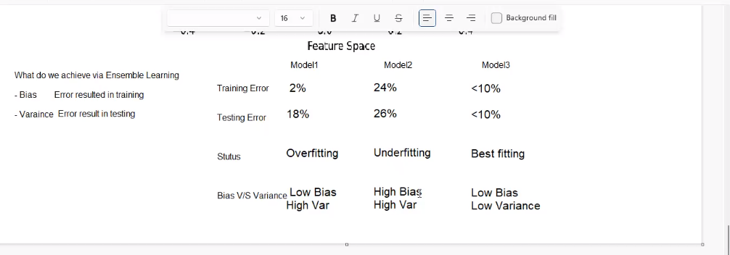

Bag of words

-Remove stop words

-stemming

-lemitization

-tokenize

Advance bag of words

